Year 11 Transition Pack for Sport and Physical Activity

Step 1:- Log onto SENECA – you can sign up for free as a student.

Step 2:- Join the following class 7mz25j676v

Step 3:- There will be assignments available on here to help you complete the work book

Step 4:- Hand in the induction pack during your first lesson to LCK for marking

Enjoy

Task 1:- The Skeletal System
Bone labels to be included:-
Cranium, sternum, ribs, vertebral column, scapula, clavicle, humerus, radius, ulna, carpals, metacarpals, phalanges, ilium, ischium, pubis, femur, patella, tibia, fibula, tarsals, talus, metatarsals
Task 1:- Label the skeletal system

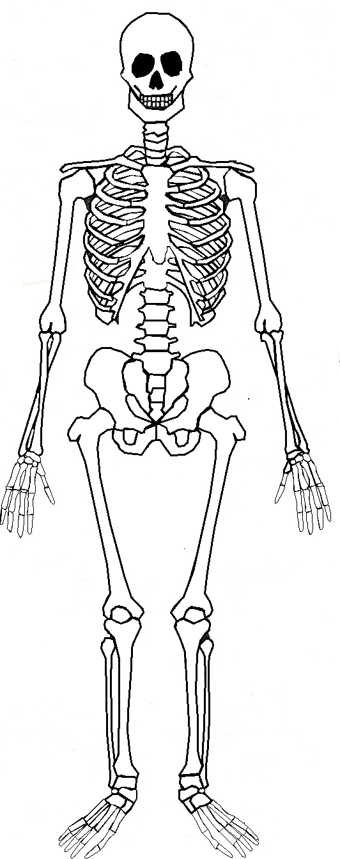

Task 2:- Difference between axial and appendicular skeleton
Describe in your own words, what is meant by the axial skeleton?
………………………………………………………………………………………………………………………………………………
………………………………………………………………………………………………………………………………………………
………………………………………………………………………………………………………………………………………………
………………………………………………………………………………………………………………………………………………
………………………………………………………………………………………………………………………………………………
Describe in your own words, what is meant by the axial skeleton?
………………………………………………………………………………………………………………………………………………
………………………………………………………………………………………………………………………………………………
………………………………………………………………………………………………………………………………………………
………………………………………………………………………………………………………………………………………………
………………………………………………………………………………………………………………………………………………
Task 3:- Joints and connective tissue
What is a joint?
………………………………………………………………………………………………………………………………………………
………………………………………………………………………………………………………………………………………………
………………………………………………………………………………………………………………………………………………
………………………………………………………………………………………………………………………………………………

The human body consists of three types of joint: What are they – the pictures give a clue as to the identification of the joints!!
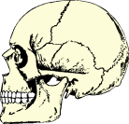
- ___________________________________________
___________________________________________
___________________________________________
___________________________________________
___________________________________________
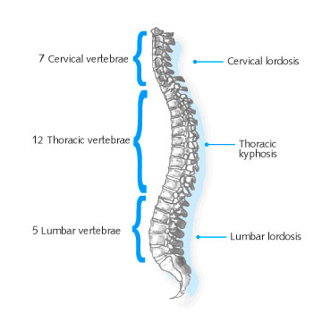
- ___________________________________________
___________________________________________
___________________________________________
___________________________________________
___________________________________________

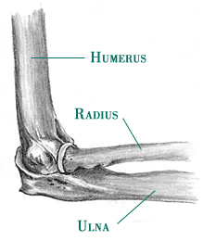
- ___________________________________________
___________________________________________
___________________________________________
___________________________________________
___________________________________________

Task 4:- Structure of a synovial joint
Synovial joints are freely moveable joints that allow us to move freely when we exercise, as a result of this they have very specific tissues that allow them to complete the job, without these tissues the joints may become damaged or ineffective.
In a synovial joint, what is the function of:-

Cartilage:-

Ligaments:-

Tendons:-

Synovial fluid:-

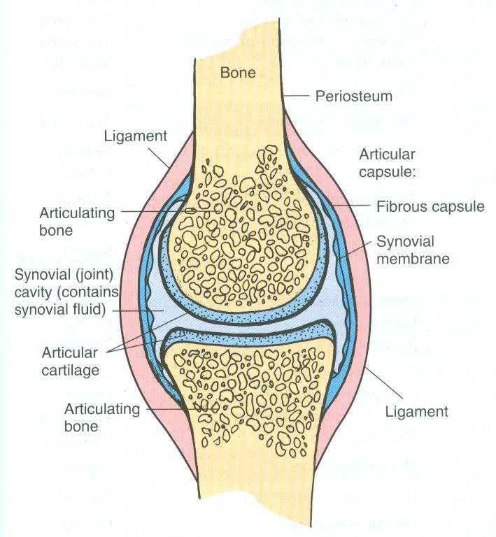

Task 5:- Muscular system:- Label the key muscles in the human body
Muscle labels to be included:-
Deltoid, latissimus dorsi, pectoralis major, trapezius, teres major, biceps brachii, triceps brachii, pronator teres, supinator muscle, wrist flexors, wrist extensors, rectus abdominus, erector spinae, Internal obliques, external obliques, iliopsoas, gluteus maximus, gluteus medius, gluteus minimus, adductor longus, adductor brevis, adductor magnus, rectus femoris, vastus medialis, vastus intermedius, vastus lateralis, bicep femoris, semimembranosus, semitendinosus, tibialis anterior, gastrocnemius, soleus
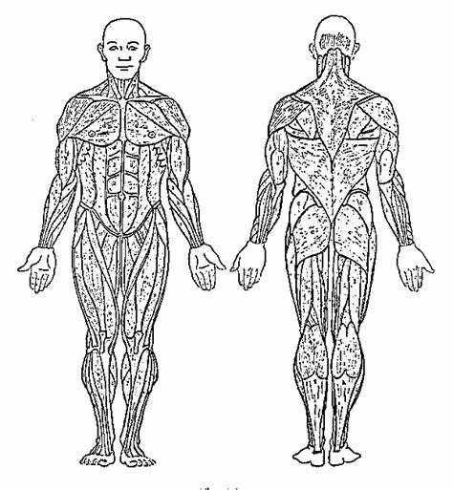

Muscle functions:-
Research the following terms and explain what they mean:-
Agonist
……………………………………………………………………………………………………………………………………………….
……………………………………………………………………………………………………………………………………………….
……………………………………………………………………………………………………………………………………………….
Antagonist
……………………………………………………………………………………………………………………………………………….
……………………………………………………………………………………………………………………………………………….
……………………………………………………………………………………………………………………………………………….
Fixator
……………………………………………………………………………………………………………………………………………….
……………………………………………………………………………………………………………………………………………….
……………………………………………………………………………………………………………………………………………….

Types of muscle contraction
Isometric
……………………………………………………………………………………………………………………………………………….
……………………………………………………………………………………………………………………………………………….
……………………………………………………………………………………………………………………………………………….
Concentric
……………………………………………………………………………………………………………………………………………….
……………………………………………………………………………………………………………………………………………….
……………………………………………………………………………………………………………………………………………….
Eccentric
……………………………………………………………………………………………………………………………………………….
……………………………………………………………………………………………………………………………………………….
……………………………………………………………………………………………………………………………………………….

Task 6:- Cardiovascular system
Labelled diagram of the heart – below is a blank diagram of the heart, you need to label the diagram with the labels from the box and then complete the table below.
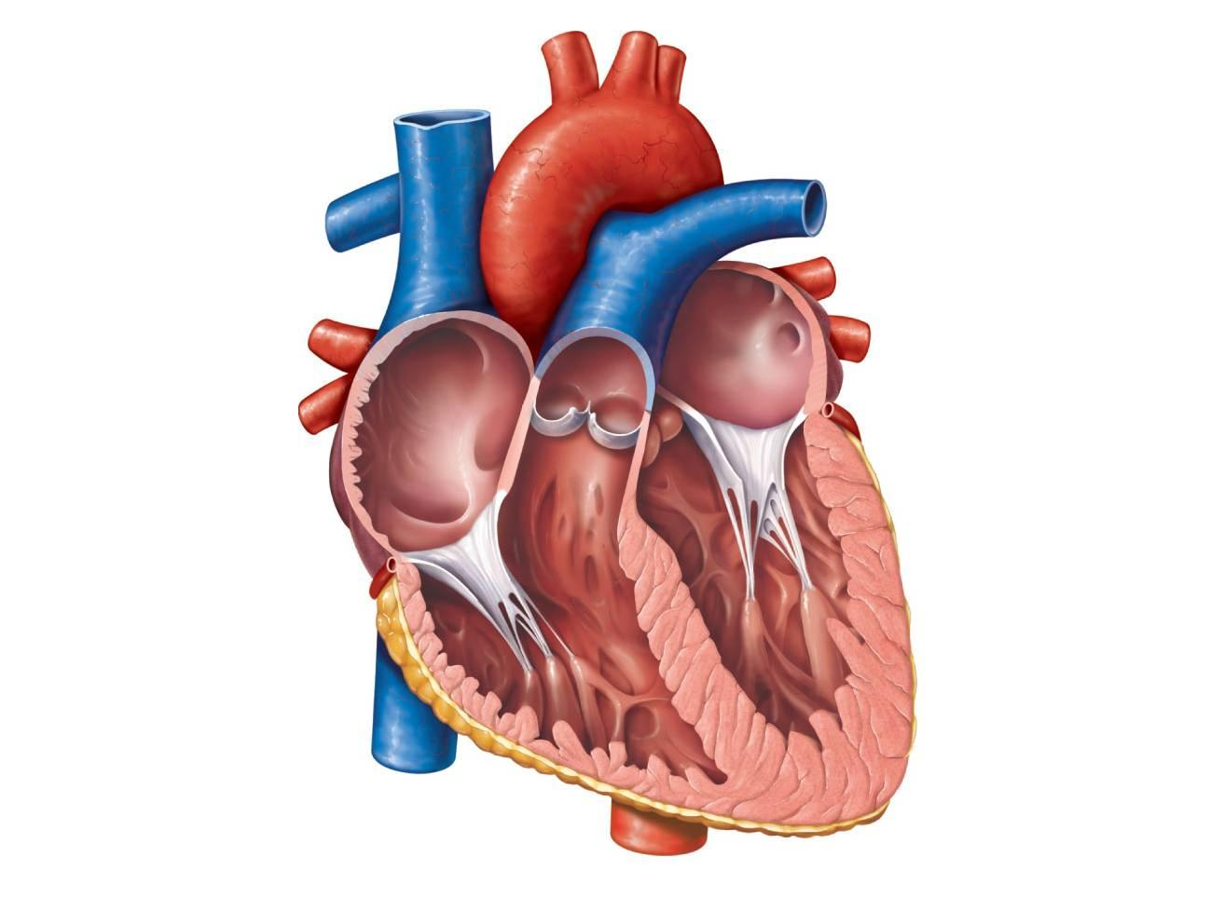
Heart labels to be included:-
Atria, ventricles, bicuspid valve, tricuspid valve, pulmonary valve, aortic valve, aorta, superior vena cava, inferior vena cava, pulmonary artery, pulmonary vein

Structure | Function
Right Atrium
Left Atrium
Right Ventricle
Left Ventricle
Bicuspid Valve
Tricuspid Valve
Pulmonary Valve
Aortic Valve
Aorta
Superior Vena Cava
Inferior Vena Cava
Pulmonary Artery
Pulmonary Vein

Task 7:- Respiratory System
Labelled diagram of the respiratory – below is a blank diagram of the respiratory system, you need to label the diagram with the labels from the box and then complete the table below.
Respiratory system labels to be included:-
Nasal cavity, epiglottis, pharynx, larynx, trachea, bronchi, bronchioles, alveoli
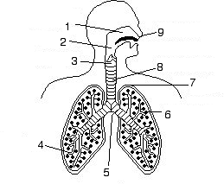

Structure | Function
Nasal Cavity
Epiglottis
Pharynx
Larynx
Trachea
Bronchi
Bronchioles
Alveoli
Diaphragm
Intercostal muscles

Unit 2:- Sports Coaching and Leadership
Within this unit of work, you will be learning to take the role of a sports coach or leader. Within this unit of work, you will be planning, running and evaluating sports sessions that you lead with younger students at Cleeve Park School or a local Primary school.
Before we can do this, we need to understand different roles that sports coaches and leaders take within a sporting context.
Sports coaches undertake different roles when leading sessions, below is a table of the different roles you can take as a coach/ leader.
Research what each phrase means and explain why it is important for a sports coach or leader to be able to take this role within a sports session.
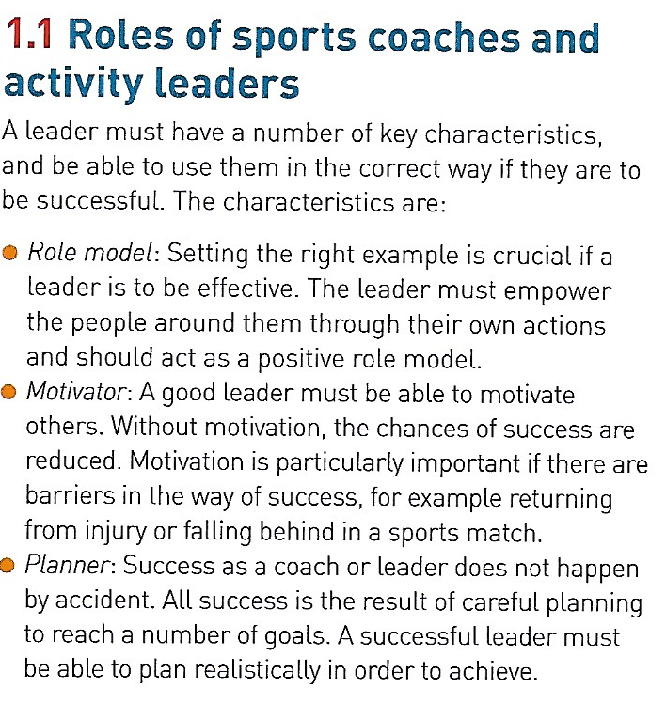
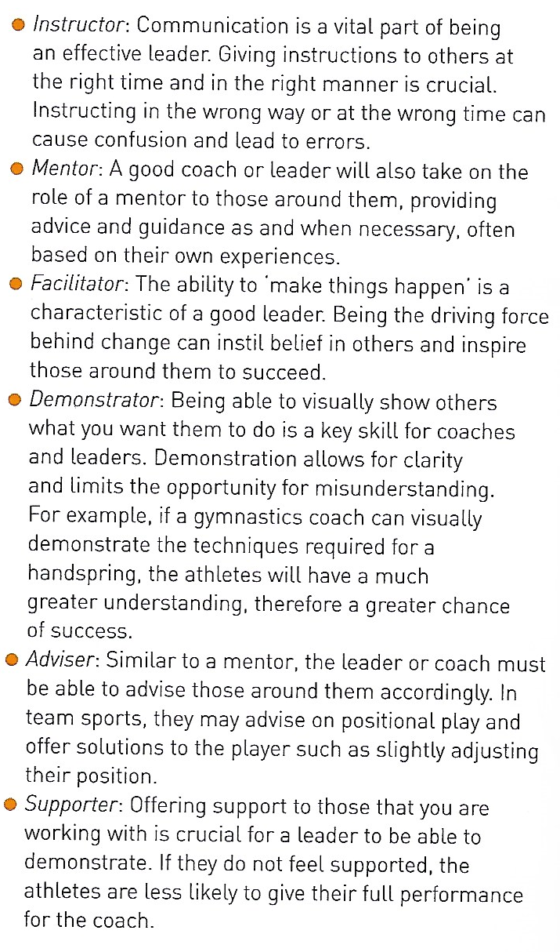
Role | Definition | Why is it needed?
Planner
Instructor
Mentor
Facilitator
Demonstrator
Adviser
Supporter
Fact finder
Counsellor
Organiser

Task 2:- Within coaching and leading, the person leading the different sessions also has to take several different responsibilities to ensure that everyone is there care is safe and well, these responsibilities vary from things such as setting ground rules for health and safety reasons to being a role model and setting a good example for the people in their care.
Examples include – setting ground rules, being fair, consistent, ethical, duty of care, safeguarding, assessing risk, promote health and wellbeing, codes of conduct, being a role model, rules and regulations
Complete a spider diagram below with ideas of why these responsibilities could be important for a sports leader? What happens if they do not take the responsibilities seriously?

TASK 3:- How do the roles and responsibilities differ depending on the role of the sports activity leader?
Leading a sports activity session can be split into three very different roles:-
Sports Coach
Sports/Activity Leader
PE Teacher
Using the information below complete the table to illustrate what is the different in the roles and the responsibilities for these three jobs.

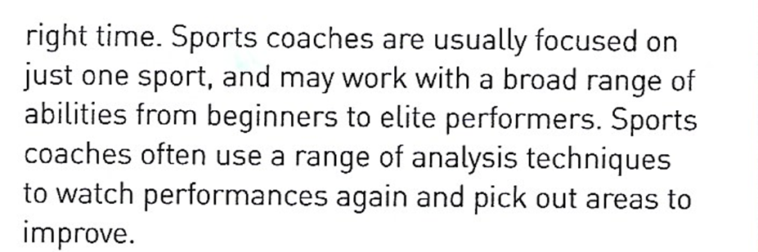
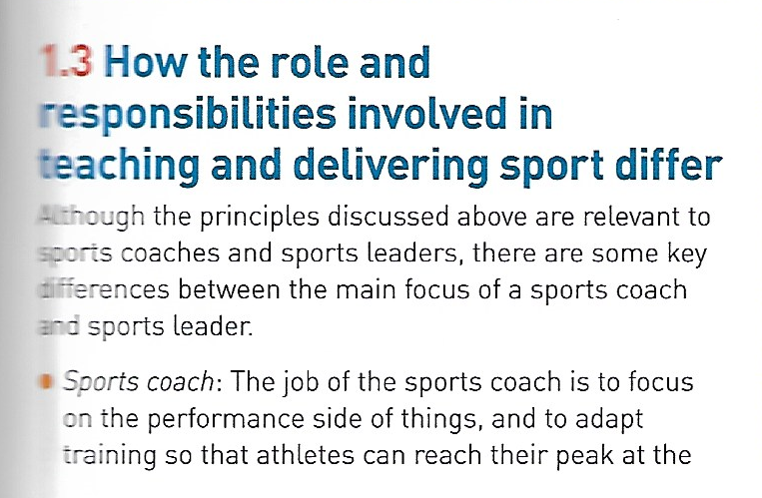

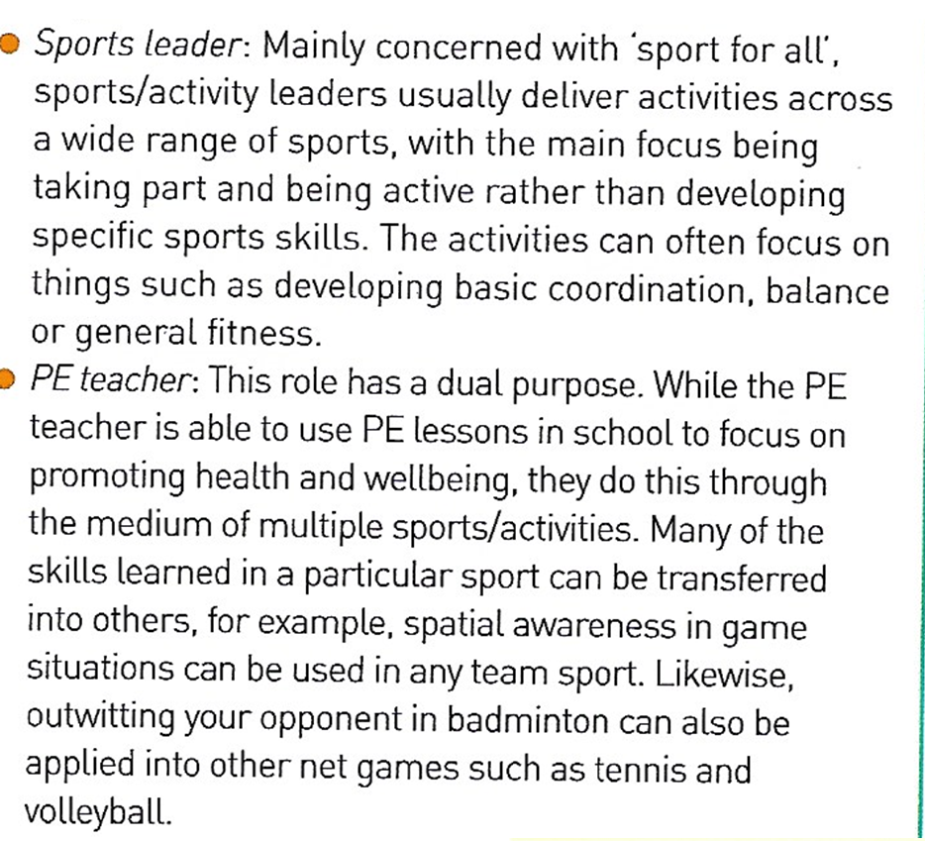

Role | Role | Responsibilities
Sports Coach
Sports Leader
PE Teacher

Task 4:- Types of Leadership:-
When you are leading your sports sessions, you will need to decide on your style of leadership, leaders will generally use one of three types of leadership styles: -
Autocratic:- This is the type of leadership where one person is in control, they issue instructions and do not listen to the opinions of other people when making decisions
Democratic:- Will listen to the opinions of others when making key decisions, will take into account opinions and generally have a group within a team or group that they speak to for opinions and advice
Laissez-Faire:- Very relaxed style of leadership where the is no real control from the leader and there is a lot of influence from the other people in the group.

In the table below, do some research into each of the styles of leadership, include your own definition and then 3 examples of groups where you think this type of leadership would be ok, giving a reason why?

Style | Definition | 3 groups and why?
Autocratic
Democratic
Laissez Faire

Task 5:- Stages of Group development:-
Research the stages of group development (forming – storming – norming and performing)
What does each stage mean?
Why is it an important stage?
What can stop a group from developing from one stage into the next stage?

