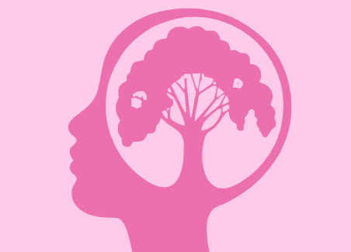

APPROACHES IN PSYCHOLOGY

AS Year 1/ Paper 2
Information & Work Booklet

This work booklet belongs to:

S. No. | Date | Content | Page No. | Progress check
 |  |  |  | Green | Amber | Red
 |  | Origins of Psychology | 3
 |  | Learning Approach: Behaviourism | 7
 |  | Potential Exam Questions | 12
 |  | Worksheet 1 | 13
 |  | Learning Approach: SLT | 16
 |  | Potential Exam Questions | 20
 |  | Worksheet 2 | 21
 |  | Cognitive Approach | 26
 |  | Potential Exam Questions | 31
 |  | Worksheet 3 | 32
 |  | Biological Approach | 34
 |  | Potential Exam Questions | 38
 |  | Worksheet 4 | 39
 |  | Biopsychology Approach | 41
 |  | Potential Exam Questions | 49
 |  | Worksheet 5 | 50
 |  | Glossary | 60
Contents Table

Origins of Psychology
What is Psychology?
The scientific study of human mind and its functions especially those functions affecting behaviour in a given context.
Can you name at least 10 behaviours that are studied in Psychology?
______________________________________________________________________________________________________________________________________________________________________________________________________________________________________________________________________________

Is Psychology a science? Or a humanities subject? Or what is also called a soft science? Choose ONE and justify your answer.
________________________________________________________________________________________________________________________________________________________________________________________________________________________________________________________________________________________________________________________________________________________________________
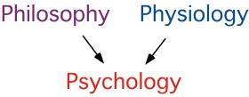

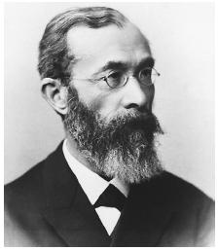
Who is Wilhelm Wundt and why is he important for Psychology?
Wilhelm Wundt opened the Institute for Experimental Psychology at the University of Leipzig in Germany in 1879. This was the first laboratory dedicated to psychology, and its opening is usually thought of as the beginning of modern psychology.
Father of Psychology
Wundt was important because he separated psychology from philosophy by analyzing the workings of the mind in a more structured way, with the emphasis being on objective measurement and control.
Wundt believed in reductionism. That is he believed consciousness could be broken down (or reduced) to its basic elements without sacrificing any of the properties of the whole.
He studied the mind scientifically using introspection.
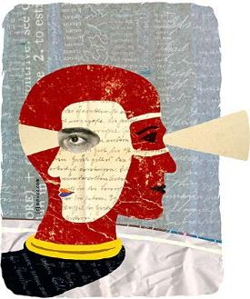
What is introspection?
Introspection is derived from a Latin meaning called- ‘looking into’. It is the first systematic experimental attempt to study the mind by breaking up conscious awareness into basic structures of thought, images, and sensations.
Wundt claimed that with sufficient training, mental processes such as memory and perception can be observed systematically using introspection. For example, in an experimental set up, under controlled conditions, participants will be presented with a stimulus such as a visual image or an auditory tone. They would then be asked to provide a description of the inner processes they experiences as they looked at the image or heard the tone.
Can you introspect about your experience of being in the class of psychology for the first time?
________________________________________________________________________________________________________________________________________________________________________________________________________________________________________________________________________________________________________________________________________________________________________

But do you think that the method of introspection devised is scientific? Answer the following hint questions that will help you derive at a critical evaluation for the method of introspection. Explain your answer in about 50 words.
- Do you think introspection will yield information that is subjective or objective in its nature?
- If Psychology is a science, should the data be subjective or objective?
- Science believes in standard procedures and set response. – T/F
- Do you think introspection will lead to a same standard response/ data from all human beings who undertake this exercise? Is this method a reliable one?
- If the data differs from person to person, can general principles or a one global theory about mind can be derived from it?
- Science is about establishing cause- effect relationship study. Do you think introspection will yield to a clear difference between whether the given behaviour is a cause or an effect?
- Introspection is about mental thoughts. Science is about studying phenomenon that can be objectively observed or measured. So is the method of introspection scientific enough?
Write your complete answer in about 100 words: is introspection a scientific process? Ensure you justify your points with reasonable elaboration.
______________________________________________________________________________________________________________________________________________________________________________________________________________________________________________________________________________________________________________________________________________________________________________________________________________________________________________________________________________________________________________________________________________________________________________________________________________________________________________________
______________________________________________________________________________________________________________________________________________________________________________________________________________________________________________________________________________________________________________________________________________________________________________________________________________________________________________________________________________________________________________________________________________________________________________________________________________________________________________________

Emergence of Psychology as a Science.
Using this and information in your textbook draw a CREATIVE timeline representing the progress of Psychology.
17th-19th Century | Psychology still considered a part of philosophy.
1879 | First experimental lab of Psychology opened by Wundt in Leipzig, Germany. Focus on scientific methods to understand the mind.
1900s | Emergence of Psychoanalysis. Sigmund Freud proposed the psychodynamic school of thought that focussed on the unconscious mind, study of dreams, and conflict within the mind.
1913 | Emergence of Behaviourism led by John B Watson. Focus on outward behaviour that is observable and measurable.
1950s | Emergence of Humanistic school of thought led by Carl Rogers and Abraham Maslow. Focus on inner self, free will, self determination.
1960s | Cognitive revolution. Human mind compared to the workings of a computer.
1960s | Learning approach. Albert Bandura tried to bridge the gap between traditional Behaviourism and new age Cognitive approach through his Social Learning Theory.
1980s | Emergence of Biological approach as a way to study human brain with the help of science & technology.
Eve of 21st century | Focus on Cognitive Neuroscience- bringing together cognitive and biological sciences.

Also remember that the scientific method in psychology refers to:
- Using methods that are objective, systematic, and replicable.
- Measurement and recording of data is done as accurately as possible
- Aims to produce results that are replicable by other researchers in order to maintain its reliability.
- Theory is developed/ modified/ falsified based on above.
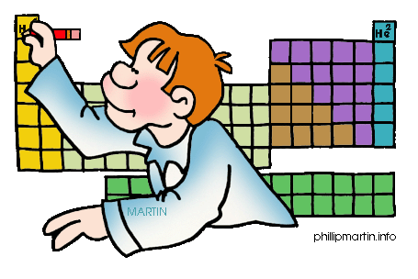
- The constant testing and development of theories completes the scientific process.

Learning Approach: Behaviourism
AO1

- As the name suggests Behaviourist approach focussed on human behaviour that is observable, measurable and objective.
- It studied behaviour in the form of stimulus-response form.
- Focussed on conditions under which learning will take place.
- John b Watson is considered as the founder of this school of thought. Ian Pavlov and BF Skinner are other two pioneers of this field.
- Behaviourists aimed to study behaviour under controlled lab conditions.
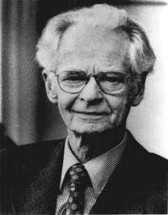
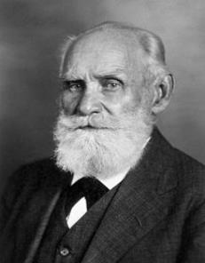
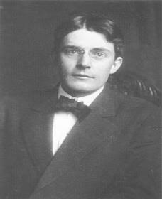
- Behaviourists also believed that basic processes that govern learning are same in humans and animals. They therefore conducted many of their experiments on animals in order to understand how human beings learn.
John B Watson Ivan Pavlov B.F Skinner

Classical conditioning by Ivan Pavlov: the famous dog experiment

Basic Assumption: | Operates on the principle of ASSOCIATION. Human beings and animals are born with reflexes. These reflexes are made of stimulus, example food, and a response such as salivation. In the context of conditioning when a 2nd stimulus, example- sound of a bell, is consistently associated with the 1st stimulus (food) and predicts its arrival (food), then the 2nd stimulus (bell) also tends to generate the same response of salivation. This process is called classical conditioning.
Pavlov’s research | In his lab experiment, Pavlov accidently discovered that dogs salivate not only in the presence of food but also salivated to a stimulus (bell) that coincided with the presentation of food if that stimulus (bell) was repeatedly presented/associated with food. Gradually, the dogs learned to associate the sound of the bell with food and produce a salivation response every time they heard the bell.  Neutral Stimulus= Bell = elicit a salivation response = conditioned response. This happened through the process of association.

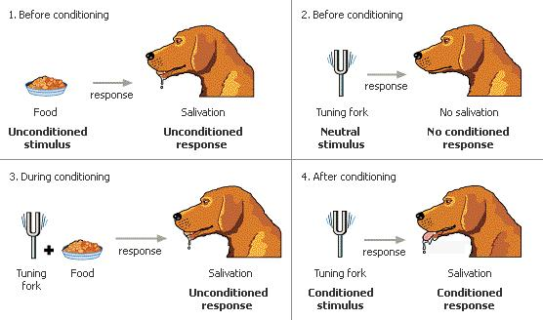
Using your understanding and the diagram above can you define what classical conditioning is? Fill in the blanks with appropriate terms to derive the definition.

Classical conditioning is learning by __________________________. It occurs when two stimuli are repeatedly paired together. One of the stimulus is called __________________________ and the other stimulus is called ____________________________. The second stimulus which is the __________________________ eventually produces the same response that was first produced by the unconditioned stimulus. This response is called ______________________________. And initially a neutral stimulus, it is now called as ______________________________.

Operant conditioning by B.F Skinner: the Skinner box experiment

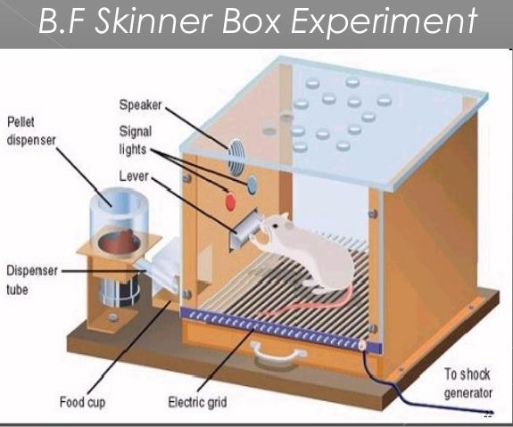
Basic Assumption | According to Skinner, behaviour is learnt through CONSEQUENCES. He proposed that behaviour are shaped and maintained by REINFORCEMENTS- positive, negative, and punishment.
Skinners’ Research | Skinner conducted his experiments with rats and pigeons in specially designed cages called- Skinner Boxes in order to investigate operant conditioning. The rats move around the cage and when it accidently presses the lever a food pellet (reinforcer) is dropped. In no time, Skinner observed that the hungry rat begins to press the lever in order to obtain food.  Skinner also observed that rats could be conditioned to perform the same behaviour (lever pressing) to avoid an unpleasant stimulus such as an electric shock.
Positive Reinforcement | Is receiving a reward when a certain desirable behaviour is performed. Example: being rewarded by your mother for babysitting your young brother.
Negative Reinforcement | Occurs when a certain undesired consequence is to be avoided by performing a particular behaviour. Example: submitting the essay on time in order to avoid staying back for detention. Therefore, negative reinforcements increase/strengthen a given behaviour.
Punishment | Is an unpleasant consequence of behaviour. Example: Being punished by the head teacher for defying school rules. In this case, the punishment aids is decreasing behaviour that is considered unpleasant.

Application of Learning Theory: Behaviourism
AO2

Can you identify if the following images represent positive or negative reinforcement & punishment
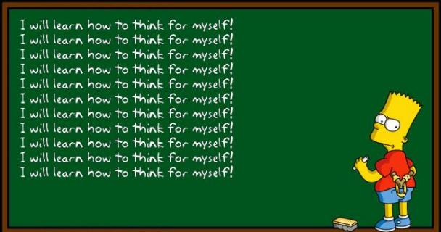

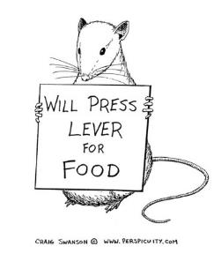
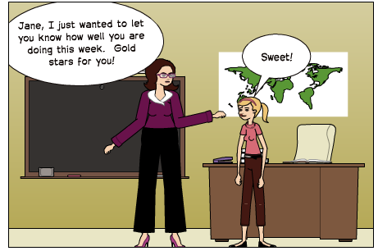
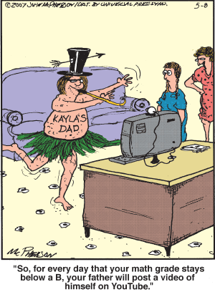

Critical evaluation of Learning Theory: Behaviourism
AO3

Classical conditioning
Strength | Weakness
POINT: There is real life application of classical conditioning.  EVIDENCE & ELABORATION: One of the applications is systematic desensitization to treat anxiety. Based on the principles of CC, it aims to eliminate fear response associated with an object (spider). The therapist tries to replaces the learnt response with a relaxation technique which is consistently presented when the patient faces the feared object. Thus, through the process of association the patient learns to respond positively (conditioned response) in the face of the feared object.  LINK BACK: This strengthens the application of CC to real life situations. | POINT: one of the weakness of CC is that it doesn’t take into consideration individual differences in human beings and across species.  EVIDENCE & ELABORATION: the relationship between conditioned response and unconditioned stimulus varies from species to species depending upon survival instinct. A dog will be easily conditioned to the sight of food rather than a sound of bell.  Similarly, in case of human beings, behaviour is governed by more factors rather than only reflexes such as emotions, situation etc.  LINK BACK: this implies that CC cannot be generalised across species and human beings and thus questions it’s validity.
Operant conditioning
Strength | Weakness
POINT: one of the main strengths of operant conditioning is that Skinner conducted his experiment under controlled conditions in a lab setting.  EVIDENCE & ELABORATION: using skinner boxes to establish the cause-effect relation of learnt behaviour put forth scientific objectivity and rigour in the finding.  LINK BACK: thus, using a well controlled experimental set up increases the reliability and validity of the findings. | POINT: one of the major drawbacks of operant conditioning experiment is that the study was conducted on animals.  EVIDENCE & ELABORATION: relying on non-human species implies that human behaviour is more complicated to be understood. The concept of free-will has been undermined and the role of reinforcement has been overemphasised.  LINK BACK: this undermines the potential of non-observable mental processes that guide human behaviour. That is to say that this approach is a reductionist approach to understand human mind.

Overall evaluation of behaviourism:
- Follows a strict scientific rigour in explaining the cause and effect of human behaviour.
- Follows the principle of objectivity and replication in its experiments.
- Focusses on behaviour that is observable and measurable.
- Views human behaviour in a rather mechanistic view and ignores the role of emotions, situational factors, and personality.

Potential exam questions
- Explain what is meant by positive and negative reinforcement in operant conditioning. ( 2+2 )
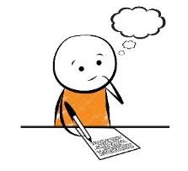
- Outline one positive and one limitation of behaviourist approach. (6)
- Outline and evaluate the behaviourist approach. (12)

How to answer the above questions
Question 1
- Define positive reinforcement + elaborate with one example = 1+1
- Define negative reinforcement + elaborate with one example = 1+1

Question 2
- Since the question is only asking about critical evaluation – one positive and one limitation you will receive no marks for outlining what is behaviourism. DELVE STRAIGHT INTO WHAT IS BEING ASKED. This is an AO3 question only.
- As mentioned above try to use the PEEL FORMAT. Highlight a strength of behaviourism. Explain that point. Lastly highlight why is it a strength. Similarly for limitation.
- Word limit approx. 120-130 words.

Question 3
- This is an essay question testing you on QUALITY OF WRITTEN COMMUNICATION. Spellings, grammar, coherence, use of key terms, use of PEELS.
- 6 marks for outlining the approach. AO1
  - Approx. 150 words
Exam tip
  - Basic assumptions of behaviourism – 50 words
  - Basic assumptions of CC + Pavlov’s research – 50 words
  - Basic assumption of OC+ Skinners’ research- 50 words
- 6 marks for evaluating the approach AO3
  - Approx. 150 words
  - 2 strengths and 2 limitations in the PEEL format.
  - Length and breadth balance: ensure that you explain a range of evaluation points (breadth) in reasonable details (length). Not too lengthy and not too brief as well.
  - Each point should be approx. 35-40 words.

IT is always a good idea to plan out your essay before diving straight into writing it. Like shown above, it ensures that you don’t miss out any important point.
Worksheet 1 Date:

Outline and evaluate the behaviourist approach in Psychology. 12 marks
Essay Plan

__________________________________________________________________________________________________________________________________________________________________________________________________________________________________________________________________________________________________________________________________________________________________________________________________________________________________________________________________
__________________________________________________________________________________________________________________________________________________________________________________________________________________________________________________________________________________________________________________________________________________________________________________________________________________________________________________________________
__________________________________________________________________________________________________________________________________________________________________________________________________________________________________________________________________________________________________________________________________________________________________________________________________________________________________________________________________
__________________________________________________________________________________________________________________________________________________________________________________________________________________________________________________________________________________________________________________________________________________________________________________________________________________________________________________________________
__________________________________________________________________________________________________________________________________________________________________________________________________________________________________________________________________________________________________________________________________________________________________________________________________________________________________________________________________
__________________________________________________________________________________________________________________________________________________________________________________________________________________________________________________________________________________________________________________________________________________________________________________________________________________________________________________________________
__________________________________________________________________________________________________________________________________________________________________________________________________________________________________________________________________________________________________________________________________________________________________________________________________________________________________________________________________
__________________________________________________________________________________________________________________________________________________________________________________________________________________________________________________________________________________________________________________________________________________________________________________________________________________________________________________________________
__________________________________________________________________________________________________________________________________________________________________________________________________________________________________________________________________________________________________________________________________________________________________________________________________________________________________________________________________
__________________________________________________________________________________________________________________________________________________________________________________________________________________________________________________________________________________________________________________________________________________________________________________________________________________________________________________________________
__________________________________________________________________________________________________________________________________________________________________________________________________________________________________________________________________________________________________________________________________________________________________________________________________________________________________________________________________
____________________________________________________________________________________________________________________________________________________________________________________

Self Evaluation
Use the level grid descriptors to identify WWW and EBI in your answer and write those comments below. Also as per your fair judgement at what level will you place your essay? Don’t worry- I will double check your assessment and provide my comments.

Level Grid
Level | 12 mark Q | Description | Evaluation | Organisation | Specialist terminology
4 | 10-12 | Accurate & well detailed | Thorough & effective | Clear & coherent | Used effectively
3 | 7-9 | Evident with occasional inaccuracies | Mostly effective | Mostly clear and coherent | Mostly used effectively
2 | 4-6 | Mostly descriptive but lacks accuracy in places | Limited effectiveness | Lacks clarity and organisation | Used inappropriately on occasion
1 | 1-3 | Limited and many accuracies | Limited, poorly focussed or absent | Poorly organised | Either absent or used inappropriately
0 | 0 | No relevant content | No relevant content | No relevant content | No relevant content

WWW

EBI

Level achieved
What can I do more to achieve a level higher?

Use green ink to write your comment.

Teachers’ comments

Learning Approach: Social Learning Theory

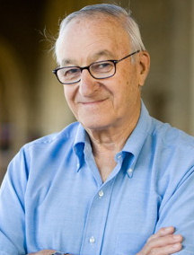
Social Learning Theory by Albert Bandura proposes that human beings are information processors and think about the relationship between their behaviour and its consequences. According to Bandura, behaviour can be explained through the process of modelling/ imitation and direct & indirect reinforcement.
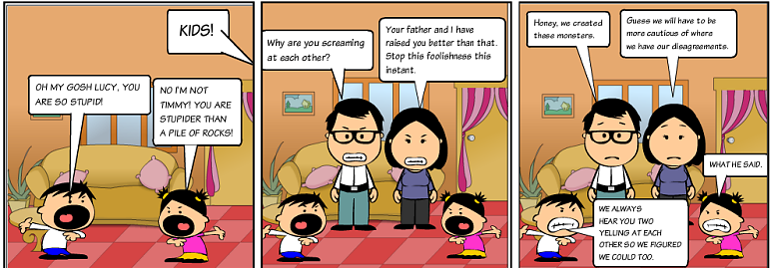
What does this theory mean? KEY CONCEPTS
- For social learning to take place a model should carry out the behaviour/attitude to be learnt.
- Individuals who carry out this behaviour are called models. Example our role models whom we like to emulate- observe, learn, and imitate behaviour that they exhibit.
- Before social learning actually takes place, a learner should be able to identify with model- is that model similar to who I am? Will I also experience the same outcome if I am in the same situation as him/her? Research by shuts et al (2010) suggests that children are more likely to identify with and preferentially learn from models who are similar to them, preferably the same sex model. Identification with a model facilitates the social learning.
- Imitation of behaviour is dependent upon various factors such as-
  - Characteristics of the model
  - Learners perceived ability to perform that behaviour. A football enthusiast will look up to the greatest footballer and try out/ model/ imitate his techniques to improve his own.
  - The observed consequences of the behaviour i.e. will imitating that football technique help him get a place in the school team or make him look like a fool.
- For imitation to take place- vicarious reinforcement plays an important role. This type of reinforcement is not directly experienced but occurs through observing someone else being reinforced for a behaviour. This is also called indirect reinforcement.
- Role of mediational process: social learning theory is considered to a bridge between learning approach and cognitive approach. There are mental processes that mediate social learning. According to Bandura there are 4 such mental processes:
  - Attention: the extent to which a behaviour is noticed.
  - Retention: how well do we remember the behaviour
  - Motor reproduction: the ability of the learner to perform the behaviour.
  - Motivation: the will to perform the learnt behaviour is dependent upon whether it will yield positive or negative consequences. That is the expectation of positive consequences is greater than expectation of negative consequence.

GET TO KNOW YOURSELF MORE!!!
Identify a behaviour/skill in you that you think you have learnt through modelling/imitating a role model. A footballer, singer, fashion icon, musician, writer, could be anything and anybody. Even your mum .. they too tend to make a good role model.

Who is your role model? _________________________________.
Why did you identify with that role model? List down at least 2 reasons as to why do you choose them to be your role model.

What action of theirs did you model? ____________________________________________________________________________________________________________________________________________________________________
What was your motivation to model that given behaviour? What did you expect after you modelled that behaviour? Was there any positive reinforcement?
______________________________________________________________________________________________________________________________________________________________________________________________________________________________________________________
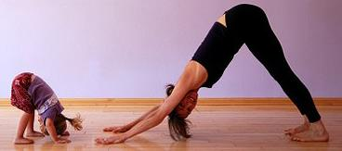
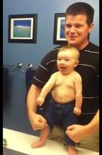
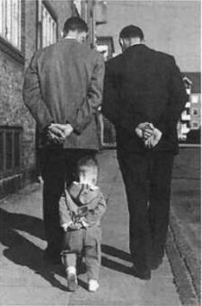

Social Learning Theory: Bandura et al (1961) KEY STUDY

Bandura, Ross and Ross (1961) tested 36 boys and 36 girls from the Stanford University Nursery School aged between 3 to 6 years old.
A lab experiment was used, in which the independent variable (type of model) was manipulated in three conditions:
- Aggressive model shown to 24 children
- Non-aggressive model shown to 24 children
- No model shown (control condition) - 24 children

The aggressive model displayed distinctive physical aggressive act towards the bobo doll. Example- striking it with a mallet, accompanied with verbal aggression such as POW. Following the experiment, children were deliberately frustrated by showing them attractive toys which they were not allowed to play with. They were then taken to a room where among other toys was a bobo doll.
Findings: children who observed the aggressive model reproduced physical and verbal aggressive responses.
Children in non aggressive model group made no physical or verbal aggressive responses.
In a follow up study, Bandura and Walters concluded that the model being awarded for aggressive acts were more likely to show high levels of aggression in their own play.

Critical evaluation of Social Learning Theory
AO3
Strengths | Weakness
POINT: social learning theory has useful real lire applications  EVIDENCE & ELABORATION: it has been suggested by a research finding by Akers (1998) that the probability of engaging in criminal behaviour increases when one is exposed models who commit crimes, identify with those models, and expect positive consequences.  LINK BACK: this implies that SLT has real life application and supports the credibility of the theory. | POINT: studies conducted to support SLT suffer from demand characteristics.  EVIDENCE & ELABORATION: Bandura’s ideas developed through observation of young children in a lab setting. As a consequence, participants may respond to demand characteristics such as they might have picked up the cue that they have to hit the bobo doll. Therefore they behaved in a way that was expected out of them. Subsequently, this may not be the case in real life.  LINK BACK: as a result these aspects undermine the validity and mundane realism of the study.
POINT: SLT explain cultural differences in human behaviour.  EVIDENCE & ELABORATION: the theory accounts for the role of media and role models in shaping behaviour. This explains the differences in behaviour as different societies have different cultural norms. As a result, SLT has proved useful in understanding a range of behaviour such as gender roles across different cultures.  LINK BACK: this further strengthens the validity of the application of theory across different cultures. | POINT: SLT underestimates the influence of biological factors.  EVIDENCE & ELABORATION: one of the consistent findings of the bobo doll experiment was that boys were often more aggressive than girls regardless of the situation. This can alternatively be explained through the biological/hormonal differences in boys and girls. Since boys have a greater level of testosterone which is related to increased aggressive behaviour. However Bandura failed to recognise this.  LINK BACK: this shows that SLT is not a comprehensive explanation of human behaviour as it hasn’t accounted for biological factors effecting human behaviour.
POINT: the SLT theory takes into consideration a more comprehensive set of factors to explain human behaviour.  EVIDENCE & ELABORATION: as demonstrated in the research study, children behaved more aggressively when they saw the model being rewarded for being aggressive. This highlights the role of cognitive processes such as expectation of consequences.  LINK BACK: this implies that SLT is less deterministic than the traditional OC and CC theories. | POINT: does social learning determine deviant behaviour or deviant attitudes that determine deviant behaviour through social learning?  EVIDENCE & EXPLANATION: Siegel & McCormick (2006) suggest that young people who possess deviant attitudes and values would seek out peers with similar attitudes and behaviours, as they are more fun ( expectation of positive outcome) than less reckless counterparts.  LINK BACK: this implies that SLT fails to explain the actual causality of behaviour.

Potential Exam Questions
- Explain what is meant by imitation, identification, modelling, vicarious reinforcement and the role of meditational process? ( 2 marks each)
- Outline and evaluate the social learning theory. (12)
- You can also get application questions as mentioned in the worksheet on the next page.
  - Whilst answering such questions, remember the question is trying to test your knowledge and your ability to apply that knowledge in the situation provided.
  - Therefore it is imperative that you outline the theory being asked (AO1), how it is being applied in the given situation (contextualisation) (AO2), and ensure you use the correct terminology.
Exam tip

Worksheet 2 Date:
Sample exam question with mark scheme
Question 1
Read the item and then answer the questions that follow.
A psychologist carried out a study of social learning. As part of the procedure, he showed children aged 4-5 years a film of a 4 year-old boy stroking a puppy. Whilst the children watched the film, the psychologist commented on how kind the boy was. After the children had watched the film, the psychologist brought a puppy into the room and watched to see how the children behaved with the puppy.
Outline what is meant by social learning theory and explain how social learning might have occurred in the procedure described above. [6 marks]
__________________________________________________________________________________________________________________________________________________________________________________________________________________________________________________________________________________________________________________________________________________________________________________________________________________________________________________________________
__________________________________________________________________________________________________________________________________________________________________________________________________________________________________________________________________________________________________________________________________________________________________________________________________________________________________________________________________
__________________________________________________________________________________________________________________________________________________________________________________________________________________________________________________________________________________________________________________________________________________________________________________________________________________________________________________________________
__________________________________________________________________________________________________________________________________________________________________________________________________________________________________________________________________________________________________________________________________________________________________________________________________________________________________________________________________
__________________________________________________________________________________________________________________________________________________________________________________________________________________________________________________________________________________________________________________________________________________________________________________________________________________________________________________________________
__________________________________________________________________________________________________________________________________________________________________________________________________________________________________________________________________________________________________________________________________________________________________________________________________________________________________________________________________

Question 2
Discuss two limitations of social learning theory. [6 marks]
__________________________________________________________________________________________________________________________________________________________________________________________________________________________________________________________________________________________________________________________________________________________________________________________________________________________________________________________________
__________________________________________________________________________________________________________________________________________________________________________________________________________________________________________________________________________________________________________________________________________________________________________________________________________________________________________________________________
__________________________________________________________________________________________________________________________________________________________________________________________________________________________________________________________________________________________________________________________________________________________________________________________________________________________________________________________________
__________________________________________________________________________________________________________________________________________________________________________________________________________________________________________________________________________________________________________________________________________________________________________________________________________________________________________________________________
__________________________________________________________________________________________________________________________________________________________________________________________________________________________________________________________________________________________________________________________________________________________________________________________________________________________________________________________________
__________________________________________________________________________________________________________________________________________________________________________________________________________________________________________________________________________________________________________________________________________________________________________________________________________________________________________________________________
__________________________________________________________________________________________________________________________________________________________________________________________________________________________________________________________________________________________________________________________________________________________________________________________________________________________________________________________________
__________________________________________________________________________________________________________________________________________________________________________________________________________________________________________________________________________________________________________________________________________________________________________________________________________________________________________________________________

Mark Scheme
Question 1
Marks for this question: AO1 = 2 and AO2 = 4
Level | Marks | Description
3 | 5-6 | Outline of social learning is generally detailed, clear and coherent. Explanation of how social learning might have occurred in the procedure is thorough with aspects of social learning applied appropriately to the context. There is effective use of terminology
2 | 3-4 | Outline of social learning is mostly clear but some detail is missing. Explanation of how social learning might have occurred in the procedure is mostly sound and appropriate. There is some effective use of terminology
1 | 1-2 | Outline of social learning lacks detail and clarity. Explanation of how social learning might have occurred in the procedure is limited. Terminology is either minimal, absent or inappropriately used.
0 | 0 | No relevant content.

Content – outline:
• learning that involves observation, imitation/copying/modelling, identification and vicarious reinforcement
• acknowledges role of cognition in learning, eg attention, motivation etc.
Possible applications:
• In the procedure children observed the actions of the boy in the film
• The psychologist exposed the children to a role model, the boy
• Using role model/boy of the same age encouraged identification
• After exposure the children would model/imitate the boy’s behaviour, stroking the puppy
• The psychologist’s comments acted as vicarious reinforcement making learning more likely • The learning might not be outwardly demonstrated but could still have been internalised (because this is social learning and therefore need not be overtly demonstrated at the time).
Credit other relevant applications.

Question 2
Marks for this question: AO3 = 6
Level | Marks | Description
3 | 5-6 | Discussion of two limitations is clear and effective. The answer is coherent and well organised with effective use of specialist terminology.
2 | 3-4 | Discussion of two limitations is mostly effective although one or both lack explanation. The answer is mostly clear and organised, with appropriate use of specialist terminology. OR One limitation is discussed at top of Level 3.
1 | 1-2 | At least one limitation is presented. Discussion lacks detail/explanation. Specialist terminology is either absent or inappropriately used. OR One limitation is discussed at Level 2.
0 | 0 | No relevant content.

Limitations – possible content:
- Difficulty demonstrating cause and effect – although Bandura research controlled variables and demonstrated behaviour was imitated it is difficult to show cause and effect in real life
• sees behaviour as environmentally determined whereas some behaviours may be innate
• Mediating cognitive factors have to be inferred so cannot measure extent of their influence
• SLT does not explain cognitive processes, leaving this to cognitive psychologists
• can explain learning of outward behaviours, SLT is not so able to explain the learning of abstract notions, eg fairness, justice etc which cannot be observed directly
• Credit comparison with other theories where presented in terms of a limitation.

Self/ Peer Evaluation
WWW

EBI

Level achieved
What can I do more to achieve a level higher?

Use green ink to write your comments above.
Teachers’ Comments

Cognitive Approach

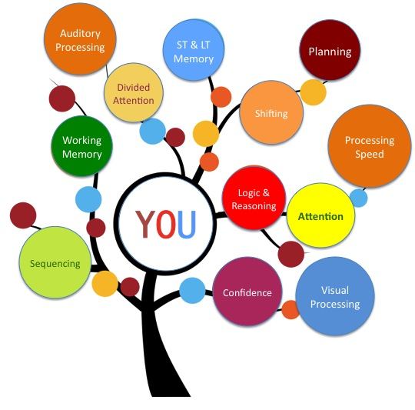
Cognitive means mental processes. According to this approach our mental processes effect our behaviour.
This approach focusses on aspects that were rejected by behaviourist – mental processes that are unobservable such as reasoning, attention, analysing, remembering, decision making etc.

Using this approach, psychologists study mental processes indirectly by making inferences about what’s going on inside people’s mind on the basis of their outward behaviour.
The internal processes are studies using two theoretical models:
- Information processing model
- Computer model

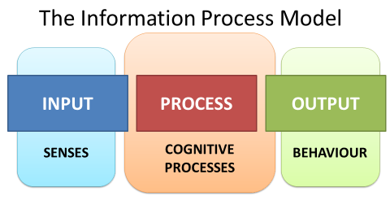
Information processing model
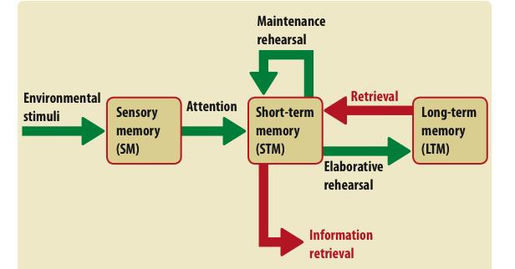
According to the information processing model the information flows through the cognitive system in a sequence of stages that include an input, storage, retrieval of information. One of the classic examples that exhibits this model is the MULTISTORE MODEL OF MEMORY

Computer model
According to this model, the mind works like a computer. Using the concept of CPU (brain) the information is coded into a more usable format, stored in designated storage devices. Artificial Intelligence is a good example that exhibits this model of mind well.
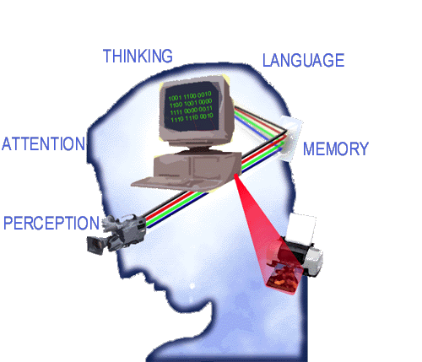

Role of Schemas
- Schemas are cognitive frameworks that help organise and interpret information in the brain. They guide our expectations from a given situation/event/person and subsequently our behaviour in order to meet those expectations.
- Schemas a short cut to interpret a situation and alter our behaviour accordingly.
- They also help us to fill in the gaps in the absence of full information.
- Schemas become more complicated with time and age as the person’s brain develops cognitively. Babies are born with motor schemas such as grasping and sucking. As adults, schemas become more detailed mental representations for any and everything.
Bugelski & Alampay (1962) conducted an experiment called rat-man. Two groups of participants were shown a sequence of pictures either a number of different faces or a number of different animals. They were then shown an ambiguous figure the rat-man.
Participants who saw a sequence of faces were more likely to perceive the figure as man, whereas participants who saw a sequence of animals were more likely to perceive the figure as a rat.

Can you explain how the influence of schema may account for this?
- However schemas also have a tendency to propagate stereotypical thinking and can also distort perceptual processing.
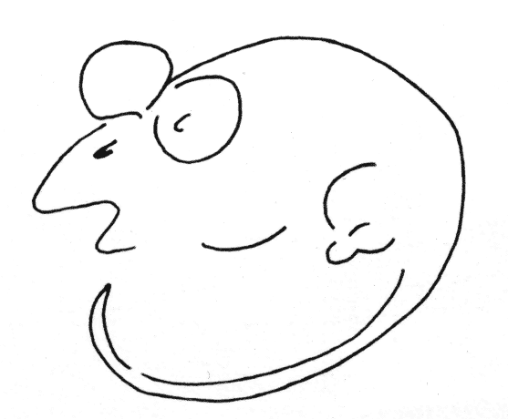
__________________________________________________________________________________________________________________________________________________________________________________________________________________________________________________________________________________________________________________________________________________________________________________________________________________________________________________________________

With your learning partner, discuss & describe the schema/ your mental representation of the following place/ event/ person.
- A teenager’s bedroom
- A office conference room
- Football match stadium
- Trip to the grocery store
- Meeting up with friends for a party
Application task

Emergence of cognitive neuroscience
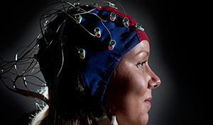
It is the scientific study of the influence of brain structure on mental processes. It addresses the questions of how psychological/cognitive functions are produced by neural circuits in the brain.
Cognitive neuroscience can look at the effects of damage to the brain and subsequent changes in the thought processes due to changes in neural circuitry resulting from the ensued damage. Also, cognitive abilities based on brain development is studied and examined under the subfield of developmental cognitive neuroscience.
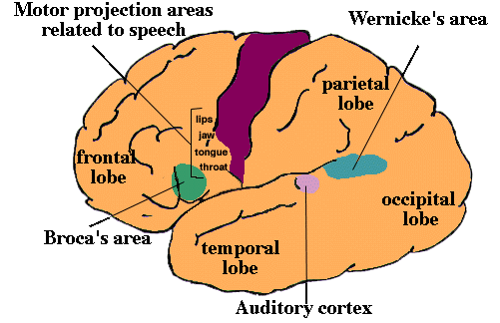
The field started to emerge as early as 1860s when PAUL BROCA identified how damage to an area in the frontal lobe, came to be known as Broca’s area could impair speech production.

Cognitive neuroscience relies heavily on the use of technology in order to study and map the brain. Below is a PET Scan ( POSITRON EMISSION TOMOGRAPHY) to differentiate between the brain activity of normal brain and an effected brain.

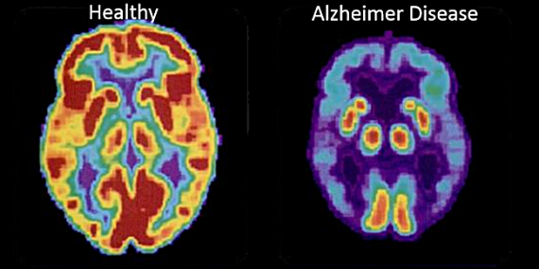

A f MRI scan (Functional magnetic resonance imaging)
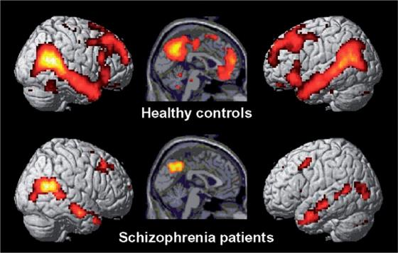

Cognitive neuroscientists study different aspects of human cognition including neural processes underlying memory, perception, attention, and awareness. They also study social cognition to understand the brain regions involved when we interact with others and impairment in these regions may characterise different psychological conditions.
PET scans and f. MRI scans have been used to identify regions of brain related to episodic & semantic memory, central executive unit of the working memory.

Critical evaluation of Cognitive Approach
AO3
Strengths | Weaknesses
POINT: cognitive approach to understand human behaviour is scientific & objective.  EVIDENCE & ELABORATION: this approach focusses on use of experimental methods to obtain evidence to understand how the mind works. It ensures rigorous controls to ensure objectivity & scientific standards.  LINK BACK: this strengthens the argument that cognitive approach to study the mind is based on sound scientific ground. | POINT: most studies are conducted under strict lab conditions. This questions the ecological validity of the results.  EVIDENCE& ELABORATION: experiments to study memory use artificial test material that are meaningless in real life situations- random words list. They fail to consider how memory is used in everyday life such forgetting and repressing traumatic experiences.  LINK BACK: as result, this conveys the argument that cognitive approach lacks real life application and has low external validity.
POINT: cognitive approach has real life application.  EVIDENCE & ELABORATION: cognitive approach can be applied to various other areas in psychology such as social cognition to understand how we form impressions of other people; or in psychopathology to understand dysfunctional behaviour and tracing it back to faulty thinking process. This has led to successful treatment of people suffering from OCD/ depression.  LINK BACK: this provides support for versatility of cognitive approach to understand different aspects of human behaviour. | POINT: this approach can be considered reductionist.  EVIDENCE & ELABORATION: this approach has over emphasised the computer model analogy to study human mind. As a result it ignores the role of emotions and motivations that govern a human mind but not a central processing unit of a computer.  As a result it cannot explain the exact causality of human behaviour.  LINK BACK: this casts a question on how comprehensive is the approach to understand human behaviour if it only compares computers to human brain.

Potential exam questions for this topic
- Explain what is meant by internal mental processes, schema, computer models, and cognitive neuroscience. (2 marks each)
- Outline how theoretical models of information processing approach and computer models explain mental processes (3 marks each)
- Outline the emergence of cognitive neuroscience (4marks)
- Outline and evaluate the cognitive approach in psychology (12)
- Describe the cognitive approach in psychology. Evaluate the research methods used by cognitive psychologists (12 marks)

Some of the key words to form your argument & link backs for evaluation

Conjunctions - write these at the beginning of paragraphs and to link points of your argument together | Implications: use these to fully explain your evaluative points and to gain extra critical commentary marks! | Comparative Phrases use these for comparing (obviously!) different therapies, explanations, theories, results of studies, approaches, etc.
Therefore | This demonstrates that | Similarly
As a result | This suggest that | In contrast
This appears to | This shows that | This reflects
Although | This provides support for | Contrary to this
Furthermore | Leading to | Whereas
In relation to | This raises the possibility of | Others would argue
Additionally | This contradicts | Conversely
An example of this | This provides reinforcement for | Equally
Where as | This agrees/does not agree with | This is weaker/stronger because
While | This shows support for | Exam tip
As such | It can be concluded that
It is clear that | This is good/bad because

Worksheet 3 Date:
Sample exam question with answer

Question 1
A research report claimed that people who believe in aliens are 17 times more liely to claim that they have seen a UFO compared to people who do not.
Explain what cognitive psychologists mean by the term schema. Refer to the information above. (4 marks)

Answer A
Schemas are packages of ideas that generate expectations. They are part of the way we think. Cognitive psychologists use them to explain thinking. People see UFOs because they believe in aliens are therefore more likely to report them.

Answer B
Schemas are used by cognitive psychologists to describe how people think about the world and their expectations. This would explain UFOs because if you don’t believe in them you wouldn’t see them. This is an example of schemas because it shows how people are thinking and it is effected by their schemas.

Answer C
In the example the schemas would be the belief that some people have that aliens do exist. Such schema are a mental framework for thinking about certain type of things such as UFOs as well as aliens. Having this belief leads to expectations & makes such people more likely to actually interpret something they see as UFO. Schemas speed up information processing or may make our cognitive systems prone to error as the UFO may not be there in the first place.

Pair up with your partner and analyse the above three answers.

Read the answers and discuss if:
- There is an accurate definition of the term schema
- Have the key terms been used in the definition?
- Has the definition of schema been applied/contextualised to the stem (situation provided in the question)
- Is the overall answer a coherent, well organised answer, with correct spellings?
- Write WWW and EBI comments in green ink for each of the answers in the space below.

 | Answer A | Answer B | Answer C
WWW
EBI

Question 2
Outline and evaluate the cognitive approach to psychology (6 marks)

______________________________________________________________________________________________________________________________________________________________________________________________________________________________________________________
______________________________________________________________________________________________________________________________________________________________________________________________________________________________________________________
______________________________________________________________________________________________________________________________________________________________________________________________________________________________________________________
______________________________________________________________________________________________________________________________________________________________________________________________________________________________________________________
______________________________________________________________________________________________________________________________________________________________________________________________________________________________________________________
______________________________________________________________________________________________________________________________________________________________________________________________________________________________________________________
______________________________________________________________________________________________________________________________________________________________________________________________________________________________________________________
______________________________________________________________________________________________________________________________________________________________________________________________________________________________________________________
______________________________________________________________________________________________________________________________________________________________________________________________________________________________________________________
______________________________________________________________________________________________________________________________________________________________________________________________________________________________________________________
______________________________________________________________________________________________________________________________________________________________________________________________________________________________________________________
______________________________________________________________________________________________________________________________________________________________________________________________________________________________________________________
______________________________________________________________________________________________________________________________________________________________________________________________________________________________________________________
______________________________________________________________________________________________________________________________________________________________________________________________________________________________________________________
______________________________________________________________________________________________________________________________________________________________________________________________________________________________________________________

Teachers comment:
WWW

EBI

Level achieved
What can you do more to achieve a level higher?

Biological Approach

This perspective focusses on the role of genetic inheritance and neural functioning in understanding the basis of human behaviour.

Biological building blocks- key concepts

Level 1 | Evolution, Genes, inheritance, genotype, phenotype | Biological approach
Level 2 | Nervous system- CNS & PNS, endocrine system, glands & hormones, fight & flight response, role of adrenaline | Bio-psychology
Level 3 | Structure of sensory, relay, & motor neurons; process of synaptic transmission; role of transmitters

Basic assumptions

- Biological structures, genes, neurochemistry, nervous system are the basis of any psychological process and/or behaviour.
- The mind is distinct from brain and also forms the physical basis of thoughts, emotions, and feelings.
- The biological approach is intricately related to the evolutionary perspective of behaviour.
Evolution and behaviour
_________________________________ proposed the theory of natural selection.
The principle of the theory is that any genetically/ psychologically (tick the appropriate one) determined behaviour that enhances ______________________ & _______________________________, will continue in future generations.
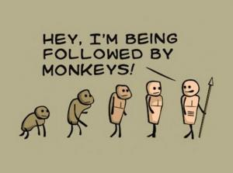
This selection of behaviour takes place ______________________ and is not pre-determined or selected by anyone else. If some traits give the possessor an advantage, it is likely to survive and be passed on to through reproduction.
According to evolutionary theory, individuals must _______________________ for basic resources ( mates, food etc) and those who survive the competition go on to reproduce and will tend to have behaviour that are more likely to lead to survival and reproductive success.
According to a study by Buss (1989) across 37 cultures found universal similarities in human mate preference. Women desired mates with resources to provide for the offspring whilst men preferred women who are attractive as an indication of fertility and reproductive value.

Influence of genes of behaviour
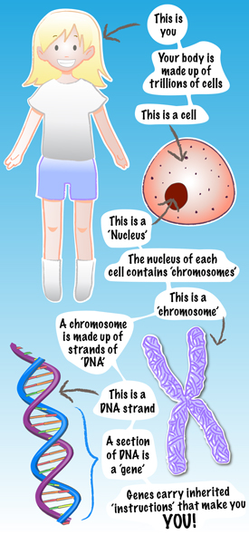
Role of genes: heredity is passing of characteristics from one generation to the other through Genes. Genes are a part of the chromosome that carry information in the form of DNA.

Genes carry the instructions for a particular characteristic such as temperament or intelligence. However, the way the gene is expressed in an individual is dependent upon environmental forces. This also form the crux of nature-nurture debate.
Genotype & Phenotype
Genotype is the actual genetic make-up or genetic code of the person. Phenotype is the way that genes express through physical, behavioural, & psychological characteristics.
The expression of the genotype is influences by environmental forces.
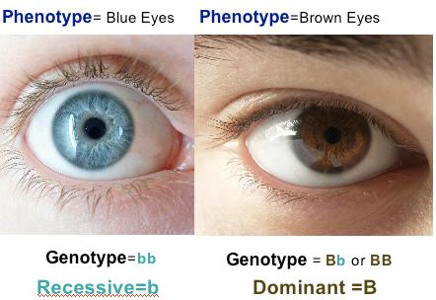
In this picture, the color of the eye is determined by the genetic code called genotype and its expression as a physical characteristic is called phenotype.

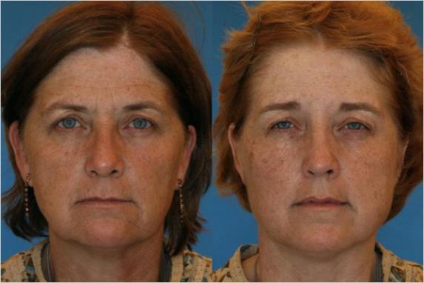
Studies of identical twins illustrate how different factors like smoking, sun exposure, depression and weight gain can influence aging. Age 52. The twin on the left smokes and has a history of more sun exposure, resulting in an older appearance than her twin of the same age. Photo: Dr. Bahman Guyuron

Nature- nurture debate
According to biological approach, genetic similarities in identical, non-identical, and family members govern the way one looks or behaves. However, there traits are also influences by the way environmental conditions affect them.
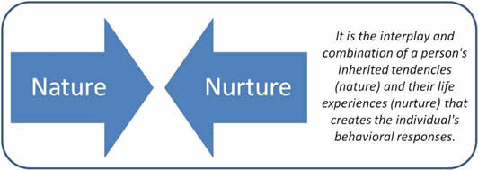
How do we study genetics/ heredity?
To understand the influence of genetic make-up and the environmental forces in determining human characteristics, the concordance rate between fraternal and identical twins and/ or biological and adoptive parents is determined.
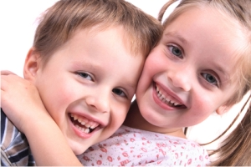
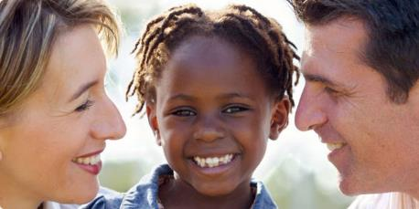
Concordance rate is the extent to which twins/ parents share the same characteristics.

Application & Research task

Phenylketonuria (PKU) is a rare genetic disorder. It can be detected early in life. However if left unchecked it causes severe learning difficulties.
TASK:
Research further on PKU.
Identify its genetic causality and physical manifestation of the disorder.
What are some of the precautions that should be taken to keep its effect under control.
Critical evaluation of Biological Approach
AO3
Strengths | Weakness
POINT: the biological approach follows a strict scientific method of research.  EVIDENCE & ELBORATION: this approach uses the experimental method for investigations. These studies take place in highly controlled environments which facilitates replication. This also increases the validity of the studies if same results can be found. Use of sophisticated technology, imaging, and recording adds to the objectivity and precision.  LINK BACK: as a result, it can be argues that biological approach is the most scientific way to understand human behaviour. | POINT: biological view offers a deterministic view of human behaviour.  EVIDENCE & ELBORATION: according to this approach human behaviour is viewed as controlled by internal, mechanical causes and processes and dismisses the role of human motivation, personality, attitudes, and cultural influences in understanding behaviour.  LINK BACK: as result, it fails to provide a comprehensive view of human behaviour and therefore weakens its stance as credible source explaining behaviour.
POINT: biological approach has real life application to explain human behaviour.  EVIDENCE & ELBORATION: research into the neurochemical imbalance in depression has led to development of drugs which minimise the imbalance and reduce the depressive symptoms.  LINK BACK: this backs the biological approach as it supports the claim of its real life application. | POINT: biological approach claims causal conclusions which may not be true.  EVIDENCE & ELBORATION: the approach explains mental illness through the actions of neurotransmitters. This is evident how a particular drug reduces its symptoms and thus, is assumed that the neurochemical in the drug causes that illness. Discovering associations between two factors doesn’t establish causality of behaviour or illness.  LINK BACK: this is a limitation of the approach as it claims causality where only associations exist between 2 factors.
Other points that can be considered: Empirical support to back up its claim of brain functioning. | Other points that can be considered: ethical issues as this approach uses non- human species to conduct neuroanatomical surgeries to understand the workings of the brain.

Potential exam questions
- Explain what is meant by genotype and phenotype (2+2)
- Outline the relationship between evolution and behaviour (4)
- Outline two strengths and two limitations of biological approach (3 marks each)
- Discuss the contribution of biological approach to our understanding of human behaviour. (12)

Worksheet 4 Date:
Sample exam question
Application question AO2
Rita and Holly are identical twins who were separated at birth. When they finally met each other at the age of 35, they were surprised at how different their personalities were. Rita is much more social and out-going than Holly. Use your knowledge of genotype and phenotype to explain this difference in their personalities. [4 marks]
______________________________________________________________________________________________________________________________________________________________________________________________________________________________________________________
______________________________________________________________________________________________________________________________________________________________________________________________________________________________________________________
______________________________________________________________________________________________________________________________________________________________________________________________________________________________________________________
______________________________________________________________________________________________________________________________________________________________________________________________________________________________________________________
______________________________________________________________________________________________________________________________________________________________________________________________________________________________________________________
Mark scheme
Level | Marks | Description
2 | 3-4 | Knowledge of genotype and phenotype is clear. Explanation of how these affect personality is clear. The answer is generally coherent with effective use of terminology
1 | 1-2 | There is limited/partial knowledge and explanation. Knowledge is clear but the explanation is missing or inaccurate. The answer lacks accuracy and detail. Use of terminology is either absent or inappropriate
0 |  | No relevant content.

Question 2. Using the planning diagram below, elaborate on the key terms mentioned in it and explain how do they evaluate the biological approach.

Biopsychology
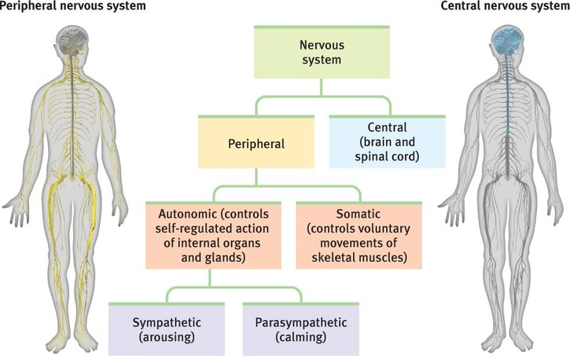

Central Nervous System
Spinal cord
- The main function of the spinal cord is to relay information between the brain and the rest of the body.
- This regulates body processes such as digestion & breathing, co-ordination of voluntary movements.
- Certain nerve circuits in the spinal cord are also responsible for reflex movements that do not involve the brain- removing our hand when we touch a hot plate.
- If the spinal cord is damaged, areas supplied by spinal nerves below the damages site will be cut off from the brain and stop functioning.
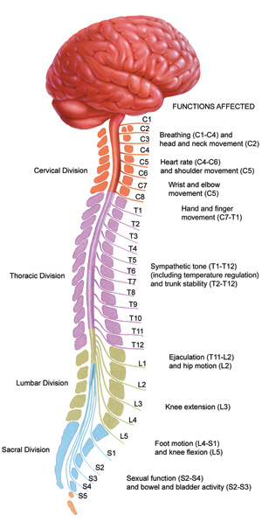
The human brain
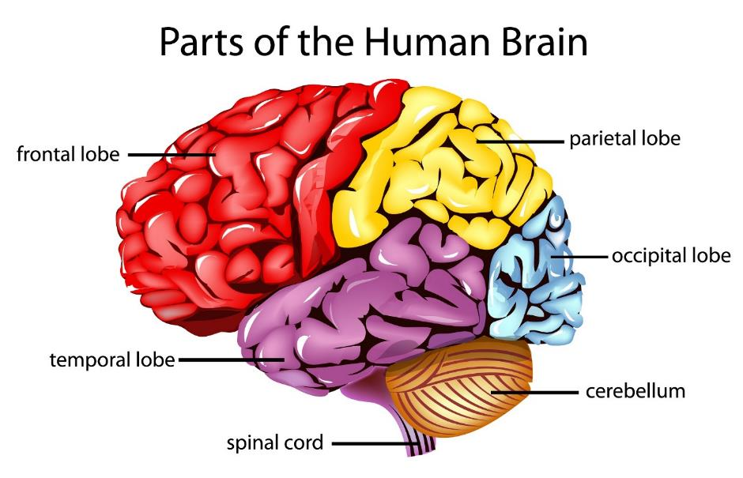
The brain is the centre of all conscious awareness. Its outer layer- CEREBRAL CORTEX is highly developed in humans and is responsible for higher mental functions.
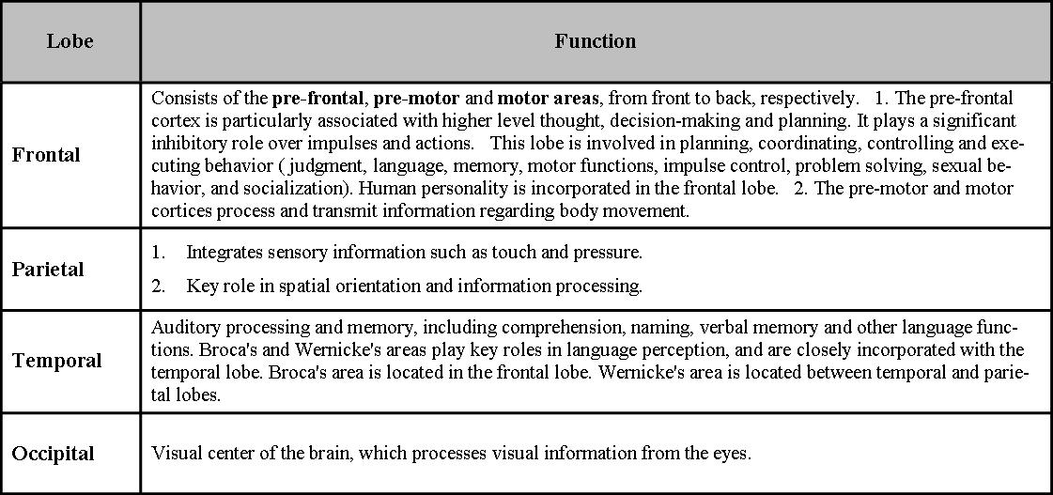
It is divided into 4 lobes:
The peripheral nervous system
The PNS transmits messages through NEURONS to and from the CNS.
It is divided into SOMATIC NERVOUS SYSTEM which controls the muscle movement and receives information from sensory receptors.
It consists of SENSORY NEURONS that are relay messages to the CNS and the MOTOR NEURONS relay information from the CNS to the rest of the body.
The AUTONOMIC NERVOUS SYSTEM is further divided into
- Sympathetic nervous system
- Parasympathetic nervous system
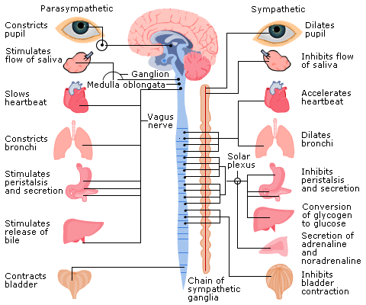

- In emergencies sympathetic nervous system cause stress and require us to "fight" or take "flight"(run away)
- In non-emergencies the parasympathetic nervous system allows us to "rest" and "digest."

Endocrine system
The endocrine system is made up of glands that produce and secrete hormones, chemical substances produced in the body that regulate the activity of cells or target organs. These hormones regulate the body's growth, metabolism (the physical and chemical processes of the body), and sexual development and function.
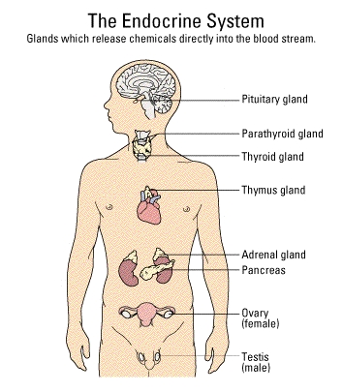
Using the statement above, derive the definition of Hormones.

Mini task
Given below is a mix of hormones and their effect on human body functioning Use your independent research to identify the right glands they belong to.

Endocrine gland | Hormone produced | Effect
Pituitary gland | - Cortisol | - Regulates females secondary sex characteristics & maintains growth of uterine lining
Hypothalamus | - Testosterone | - It controls hormone secretion in other glands.
Thyroid | - Epinephrine & norepinephrine | - Regulates male secondary sex characteristics
Pancreas | - Estrogen/ progesterone | - Effects the heart rate and the body metabolic rate.
Adrenal cortex | - Thyroxine | - Prepares the body for fight or flight response
Adrenal medulla | - Glucagon & insulin | - Regulates cardiovascular and anti-inflammatory functions.
Ovaries | - Controls the functioning of the master gland | - Stimulates release and absorption of glucose
Testes | - Master gland | - It control the functioning of the pituitary gland

Write the correct combination for each of the glands below.

Hypothalamus
Pituitary gland
Thyroid
Pancreas
Adrenal cortex
Adrenal medulla
Ovaries
Testes

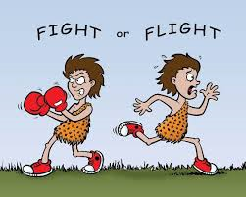
Fight- Flight response

ACUTE STRESS: This is stress resulting from specific events or situations that involve novelty, unpredictability, a threat to the ego, and leave us with a poor sense of control. This ‘on the spot’ type of stress can be good for you because the stress hormones released help your mind and body to deal with the situation.

CHRONIC STRESS: This is stress resulting from repeated exposure to situations that lead to the release of stress hormones. This type of stress can cause wear and tear on your mind and body

CHRONIC STRESS
- During a stressful situation the body moves from parasympathetic mode to a sympathetic state through the command centre Hypothalamus which sends a signal in the form of CRH to the master gland- pituitary gland.
- As a result the pituitary gland releases the hormone called ACTH- Adreno-Cortico-Trophic-Hormone.
- This stimulates the Adrenal Gland to release the hormone called Adrenaline into the blood stream.
- Adrenaline in turn puts the body on an alert mode to deal with stress- physiological changes such as increased heart rate, rapid breathing, contracted rectum, dilated pupils etc.
- Once the stressful situation is dealt with- the parasympathetic system brings the body back to rest-&-digest state.

ACUTE STRESS
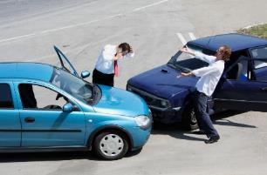
- In the face of sudden threat the SNS sends alert signals to the ADRENAL MEDULLA.
- As a result the adrenal medulla sends ADRENALINE to the entire body.
- Along with the bodily readiness, the adrenaline also increases the blood glucose levels & fats to supply the body with high energy levels.
- Once the stressful situation is dealt with- the parasympathetic system brings the body back to rest-&-digest state.
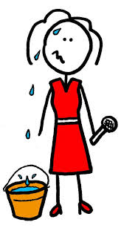
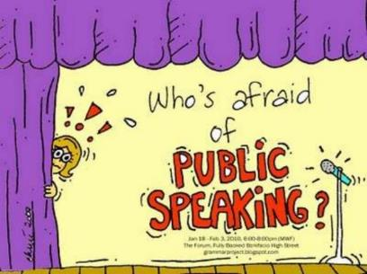

Given to you is a handout which critically analysis the purpose of fight & flight response. Is fight and flight response gender based? Can it promote co-operation amongst human beings? Or is there an alternative explanation of stress behaviour than fight or flight response.
Your task is to read that information- discuss the pros and cons of the fight and flight approach with evidence to support your stance.

Potential exam questions
Central nervous system
- Name and briefly outline two divisions of the human nervous system. (4)
- Identify two divisions of the autonomic nervous system (2)
- Outline the role of sympathetic and parasympathetic nervous system. (4)
Endocrine system
- Outline the functions of the endocrine system (6)
- Explain the relationship between endocrine glands and hormones (4)
- Outline the role on one endocrine gland and of one hormone that it produces (4)
Fight or Flight response.
- Explain what is meant by a Fight or Flight response? (2)
- Outline the fight or flight response including the role of adrenaline (6)
- Outline and evaluate the fight and flight response (12)

Exam tip

Study tip: this part of the specification is loaded with new terms and technical phrases. To ensure that you’re on top of your game for this- memorise using cue cards, mnemonics, acronyms, mind maps, doodling, multiple choice questions quiz, or /and glossary list

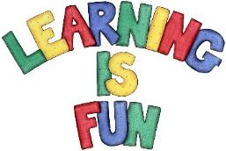
https://quizlet.com/79942178/flashcards follow the link for an online quiz on the topics that have been covered in class. There may be a few questions that are new to you .. go ahead and test your luck and learn more!

Worksheet 5 Date:
Sample exam questions
Question 1

Complete the following sentence. Choose 1

The somatic nervous system
A comprises of two sub-systems.
B connects the central nervous system and the senses.
C consists of the brain and spinal cord.
D controls involuntary responses.

Which one of the following responses results from the action of the sympathetic division of the autonomic nervous system?

A Decreased pupil size
B Increased digestion
C Increased heart rate
D Increased salivation

Which two of the following statements about the fight or flight response are correct? Choose two responses only.

During the fight or flight response:
A there is a decrease in the release of adrenaline
B the flow of blood is diverted from the surface of the skin
C the process of digestion is inhibited
D the parasympathetic division is in control of functioning
E there is a reduction in the rate of respiration

Question 2

Bob was telling his friend his friend James about his recent frightening encounter.

‘I was walking home by myself in the dark. Suddenly I heard a shuffling noise behind me and a faint smell of rotting flesh. I realised it was coming closer. I saw a bus at the bus stop and decided to run. I could heard the footsteps coming closer. I don’t think I have ever moved so quickly. I leapt onto the bus- shaking, sweating and my heart was beating really fast. I turned to see the empty as the bus pulled away from the stop. Had I imagined it?’

Outline the role of the central nervous system and the ANS in behaviour. Refer to Bob’s experience in your answer (4)

__________________________________________________________________________________________________________________________________________________________________________________________________________________________________________________________________________________________________________________________________________________________________________________________________________________________
________________________________________________________________________________________________________________________________________________________________________________________________________________________________________________________________________________________________________________________________________
________________________________________________________________________________________________________________________________________________________________________________________________________________________________________________________________________________________________________________________________________
________________________________________________________________________________________________________________________________________________________________________________________________________________________________________________________________________________________________________________________________________
________________________________________________________________________________________________________________________________________________________________________________________________________________________________________________________________________________________________________________________________________
________________________________________________________________________________________________________________________________________________________________________________________________________________________________________________________________________________________________________________________________________
______________________________________________________________________________________________________________________________________________________________________________________________________________________________________________________

Question 3

Research has shown that people who get ill have often experienced major stressful life events in the previous few months and years such as getting married, divorce, death, etc. A researcher investigated this relationship between illness and life events. She gave 150 participants a questionnaire in which they the number of major life events from the list of 20 they had experienced over the past three years. This was compared to the number of days off work through illness the participants had had over the same period of time. The researcher found a positive co-relation between the variables.

- In the context of investigation above- what is meant by positive co-relation between the two variables (2+2)
_______________________________________________________________________________________________________________________________________________________________________________________________________________________________________________________________________________________________________________________________________________________________________________________

- Suggest a suitable graphical display that the researcher could have used to show this relationship. (1)
_________________________________________________________________________________________________________________________________________________________________________________________________________________________________

- Explain one advantage of co-relation studies. Refer to the investigation mentioned above. (2)
_________________________________________________________________________________________________________________________________________________________________________________________________________________________________

- Explain the difference between co-relation & experiments. (3)
_________________________________________________________________________________________________________________________________________________________________________________________________________________________________

Neurons and Synaptic Transmission

Key terms
- Neurons
  - It is the basic building block of the nervous system. These cells are responsible for transmitting electrical and chemical messages across the nervous system.
- Synapse
  - It refers to the conjunction of the end of axon of one neuron and the dendrites of the next neuron.
- Synaptic transmission
  - It refers to the process by which a nerve impulse passes across the synaptic cleft from one neuron to another neuron.
- Neurotransmitters
  - These are chemical substances that play a major role in the functioning of the NS by transmitting nerve impulses across a synapse.
- Sensory neurons
  - These carry messages from the PNS to the CNS. They therefore have a longer dendrites (in order to carry messages across the body) and shorter axons.
- Relay neurons
  - As the name suggests, they relay messages between sensory neurons and other motor neurons.
- Motor neurons
  - These connect the CNS to effectors such as muscles and glands. They have short dendrites and long axons.

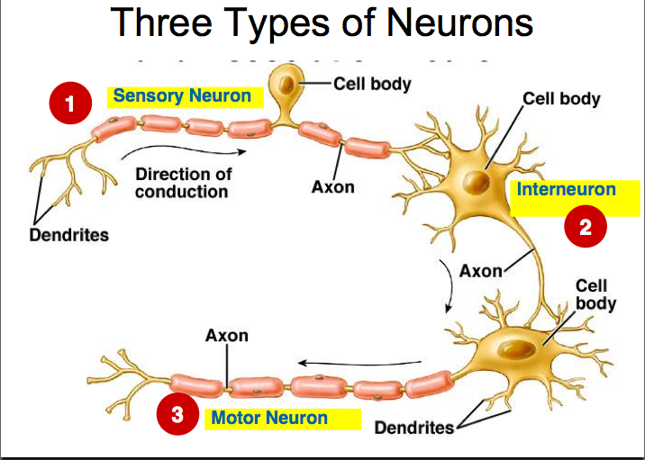

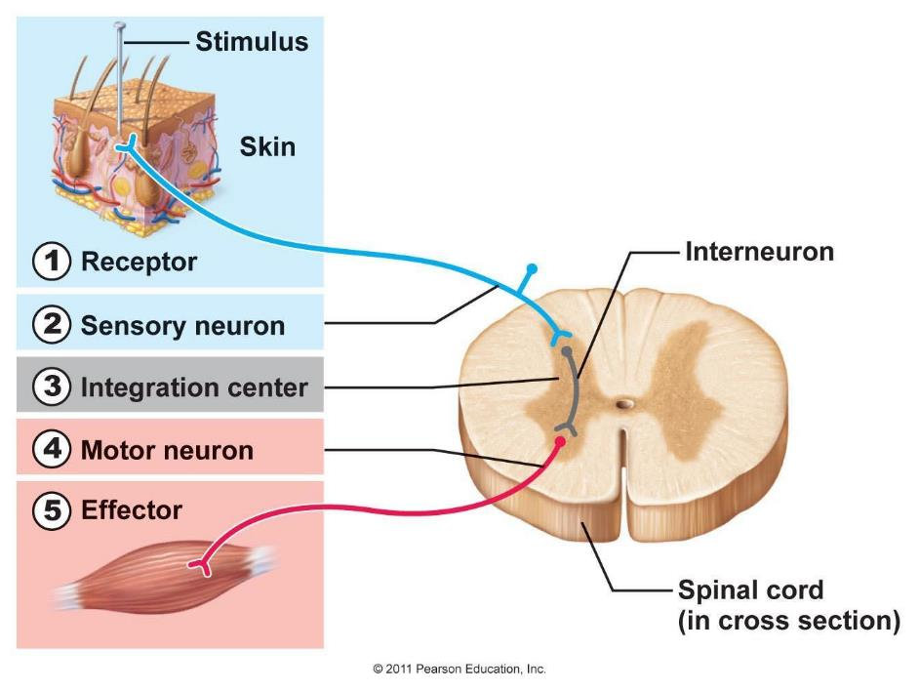
The above diagram represents a simple version of a rather complicated network of neurons. Notice the three types of neurons and direction of the flow of electric impulse from sensory to motor via the relay neuron.

Structure of a neuron
It is advisable that you practice drawing the structure of the neuron for learning and memorising its components.
Exam tip
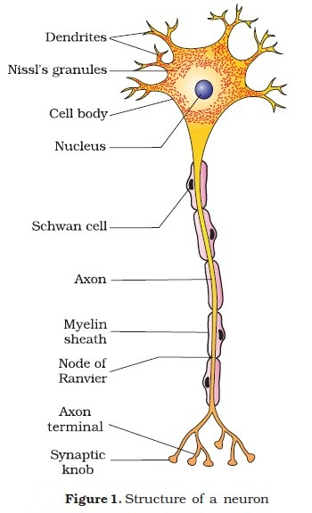
Structure of a neuron
Cell body: it includes the cell nucleus containing the genetic material of the cell.
Dendrites: protruding from the cell body, they carry nerve impulses from other neurons towards the cell body.
Axon: this carries the impulses away from the cell body towards the end.
Myelin sheath: it protects the axon and speeds up the electrical transmission of the impulse. This protective shield is made up of proteins and lipids produced by the shwan cells.

Nodes of Ranvier: this segments the axon to speed up the electrical impulse by forcing it to jump across the gaps along the axon.
Terminal buttons/ synaptic knob: are responsible for communicating with the next neuron across a gap called synapse.

Neuron firing: when in a resting state, the inside of the cell is negatively charged. When a neuron is activated by a stimulus, the inside of the cell becomes positive for a split second causing the ACTION POTENTIAL for a moment. This creates an electric impulse that travels down the axon towards the end of the cell.

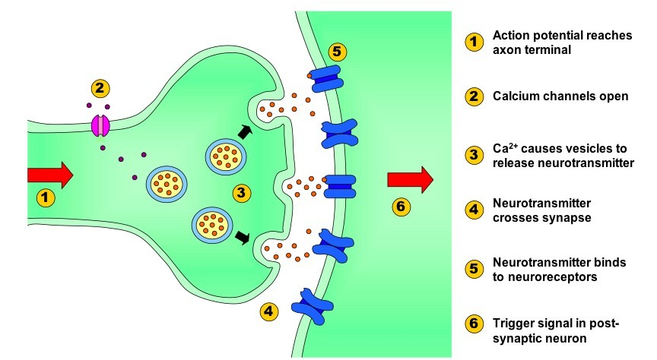
Synaptic transmission
Stages of transmission
- Once the action potential is generated, the electrical impulse needs to be transferred to another neuron via the SYNAPTIC GAP between the two neurons.
- The end of the pre-synaptic neuron, consists of SYNAPTIC VESICLES that contain chemical messenger that assist in transmission of electric impulse.
- As the action potential reaches the end of the axon, it causes the vesicles to open up.
- Once the chemical is released into the gap, it binds to the receptors of the post synaptic neuron (dendrites of the next neuron) and thus gets activated.
- In the post synaptic neuron the chemical messenger is converted into an electrical charge and thus fires transmission in that neuron.
- The whole process of synaptic transmission takes only a fraction of a second.

Excitatory and Inhibitory neurotransmitters
A nerve cell can receive both excitatory post synaptic potential (EPSP) and inhibitory post synaptic potential (IPSP). The likelihood of firing is determined by adding up the excitatory and inhibitory synaptic input.

Examples of excitatory neurotransmitter: acetylcholine & Noradrenaline
Examples of inhibitory neurotransmitter: GABA and Serotonin.

Mini task

Fill in the gaps using the terms provided below in the box.

The knee jerk reflex is an example of a reflex arc.
A stimulus, such as a hammer, hits the knee. It is detected by the sense organs in the _________________________, which conveys a message along the __________________________. The message reaches the _______________, where it connects with an ____________________. This then transfers the message to a ___________________. This then carries the message to an ____________________, such as a muscle, which causes the muscle to contract and hence, causes the knee to jerk.

Effector, CNS, sensory neuron, PNS, motor neuron, relay neuron.

Potential exam questions
- Briefly explain the process of synaptic transmission (4)
- With the reference to the neurotransmitters explain what is meant by excitation and inhibition. (4)
- Distinguish between a sensory neuron and a relay neuron. (2)

Attempt the multiple choice questions on page number 130-131 of your textbook.

Learning tips
- Prepare Cue cards for each of the topic covered in class. Don’t leave them for the last moment.
- Listen, understand, analyse, learn, teach a buddy!
- Attempt exam questions using key terms and phrases.

GLOSSARY of KEY TERMS learnt today
Topic | Key Term | Meaning

GLOSSARY of KEY TERMS learnt today
Topic | Key Term | Meaning

GLOSSARY of KEY TERMS learnt today
Topic | Key Term | Meaning

