Money Market Video Clip
Watch the Money Market Video Clip and answer the questions below:
- What is the money market?

- What were the two types of money market instruments mentioned?

- What is the purpose of the money market?

- What is the main differences between the money market and capital market (Equities and bonds)

Worksheet – Types of Money Market Instruments Research Task
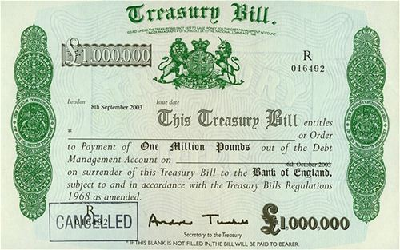
Carry out online research to find out the following information about Treasury Bills:
You may want to use: http://www.dmo.gov.uk/

- Who issues Treasury Bills and what is their purpose?

- How frequently are Treasury Bills issued?

- How do investors make a return?

- How long do they take to mature?

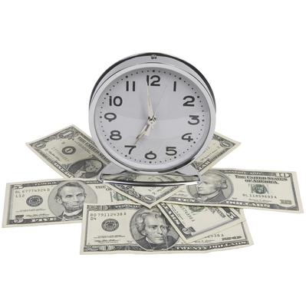
Worksheet – Types of Money Market Instruments Research Task
Carry out online research to find out the following information about Certificates of Deposits (CDs):
You may want to use: http://www.bankofengland.co.uk/statistics/Pages/iadb/notesiadb/wholesale_sterlingcds.aspx

- Who issues CDs?

- How long can they be held for?

- How do they work?

- How do investors make a return?

Worksheet – Types of Money Market Instruments Research Task
Carry out online research to find out the following information about Commercial Papers (CPs):
You may want to use: http://www.investopedia.com/articles/investing/070313/introduction-commercial-paper.asp
- Who issues CPs and why?

- How long can they be held for?

- How do they work?

- How do investors make a return?

