Investing in buy-to-let properties
Watch the video clip on investing in Buy-to-let properties and answer the questions below:
- What are the key things to consider when deciding to invest in a buy-to-let property?

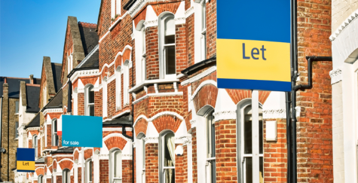

- What obligations are there when becoming a landlord?

- What are the main economic risks associated with investing in buy-to-let properties?

