The Bretton Woods Agreement
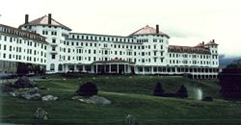
July 1944 saw delegates from 44 countries meet at a Mount Washington Hotel in Bretton Woods, New Hampshire, USA. The meeting was held to look at restructuring the international financial system, post-war. It was considered that economic conflicts between countries in the 1930s had been a large factor towards causing the World War II.
The principal negotiators at the meeting were the US, represented by the US Treasury's Harry Dexter White, and the UK's John Maynard Keynes, who was serving as UK Treasury adviser. Chairing the meeting was Henry Morgenthau, the US Treasury Secretary, from the only country that was likely to emerge from the war with a strengthened economy.
The meeting was part of the process led by the US to create a new international world order based on the rule of law.
The conference
There were two key problems on the agenda to solve:
- The creation of a stable system of exchange rates

- The rebuilding of Europe’s war-damaged economies
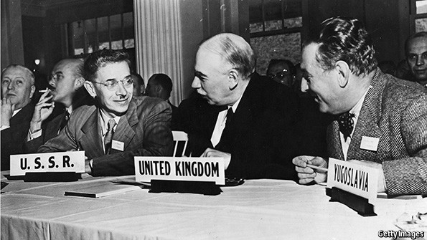
This saw the creation of two new international organisations:
The International Monetary Fund (IMF) was created to tackle the first issue. It was set-up to enforce a set of fixed exchange rates that were linked to the dollar. Countries in balance of payments difficulties could receive short-term help from the IMF to avoid devaluation, and it could sanction changes in exchange rates when necessary. The Bretton Woods system, as it became known, gave the US Dollar (which was linked to gold) - the main world currency and allowed the US to run a trade deficit without having to devalue.
The International Bank for Reconstruction and Development (The World Bank) was also established to facilitate long-terms loans to help restore the economies destroyed by Word War II.
The US contributed the most money to both institutions and gained the most voting rights, giving it a veto over major policy decisions. The US also helped the European recovery by contributing additional funds through the Marshall Plan when the World Bank's efforts proved inadequate. World trade among developed countries grew rapidly in the 1950s and 1960s, boosting world output and raising the standard of living, especially in Europe and Japan.
The demise of Bretton Woods
By the 1970s, the cost of the Vietnam War and the running of trade deficits put the US Dollar under pressure.
By 1971, the US only had reserves of gold sufficient to cover 22% of the US dollars in issue. Before the collapse of Bretton Woods, the French central bank was buying US dollars with French francs, and converting the US dollars into gold at US$35 per ounce. It has been estimated that the true market price of gold in 1971 should have been US$103 per ounce. On 15th August 1971, President Nixon announced the end of the gold standard for the US dollar.
This led to the abandonment of fixed exchange rates and the introduction of floating rates, where the value of all the main currencies was determined by market trading.
Attempts to forge a new Bretton Woods agreement on currencies in the 1970s failed, although the IMF still retained its role of helping countries cope with major currency crises - including Britain in 1976.
Financial globalisation
The end of the Bretton Woods system saw two decades of financial globalisation, encouraged by the deregulation not just of currency markets, but also of rules about banking and investment.
This led to increased flows of private money to rich and poor countries alike, which helped boost growth but also created greater instability.
The rapid reversal of such private sector flows when currencies were threatened with devaluation was the central cause of the Asian financial crisis in 1997-98, which spread to Russia and eventually Argentina.
The resources of the IMF proved inadequate to compensate for the run on their currencies, and the adjustment proved painful, with sharp falls in GDP.
Since then, many Asian countries, including China, have accumulated large currency reserves to insulate themselves against future crises, avoiding the need to call on the IMF.
Questions:
- What were the catalysts for the Bretton Woods meeting?
________________________________________________________________________________________________________________________________________________________________________________________________________________________________________________________________________________________________

- In one sentence, describe the how the Bretton Woods Agreement solved the issue of creating a stable system of exchange rates;
________________________________________________________________________________________________________________________________________________________________________________________________________________________________________________________________________________________________

- Why did President Nixon announce the end of the Bretton Woods Agreement in 1971?
________________________________________________________________________________________________________________________________________________________________________________________________________________________________________________________________________________________________

- Following the abandonment of the agreement, how did exchange rates work?
________________________________________________________________________________________________________________________________________________________________________________________________________________________________________________________________________________________________

- Can you think of anything similar to the Bretton Woods Agreement that exists today?
________________________________________________________________________________________________________________________________________________________________________________________________________________________________________________________________________________________________

